Name:______________________ Class Period:_________

How Do you like your kool-aid?

We will be making 5 different concentrations of Kool-Aid (0.1 M, 0.3 M, 0.5 M, 0.7 M, and 1.0 M). You will taste the Kool-Aid solutions you make to determine how you like your Kool-Aid.

Pre-Lab Questions: Show your work for each calculation and write your final answer on the line. Use correct units.

- Kool-Aid is mostly sugar (C₆H₁₂O₆) with added color and flavorings. You can assume the molar mass of Kool-Aid is that of sugar. Calculate the molar mass of Kool-Aid.

_____________

- Calculate the mass (in grams) of Kool-Aid needed to make 0.1 L solutions of the following concentrations:

0.1 M_____________

0.3 M _____________

0.5 M _____________

0.7 M _____________

1.0 M _____________

- When Kool-Aid is dissolved in water, what is the solute and what is the solvent?

Solute: ______________

Solvent: _______________

Safety
Normally in the chemistry laboratory there is no eating or drinking. However, for this lab we will taste Kool-Aid solutions in order to learn about concentration. Special care must be taken so that nothing becomes contaminated.
- If at any time you do not want to taste the solutions, you do not have to!
- Do not pour the Kool-Aid powder back into the container if you pour out too much. Dispose in the trashcan.
- If any Kool-Aid powder touches the lab bench or balance, dispose of it.

Procedure
- Obtain 6 cups. With the Sharpie marker, label each of 5 the cups with the following concentrations: 0.1M, 0.3 M, 0.5 M, 0.7 M and 1.0 M. The 6th cup is for water.
- Each group member will be responsible for making at least one solution. Decide who is making which solutions. If you have less than 5 people in your group, someone will make 2 solutions.
- Weigh out the correct amount of Kool-Aid powder in each cup by putting your cup on the balance, taring the mass to zero, and putting the correct mass of Kool-Aid powder into the cup.
- Fill cups to the top line. This is exactly 0.1L of water.Stir with the stick.
- Observe and taste the solutions you have made. You can have a "designated taster" or you can pour a little of the solution into separate cups for each group member to taste. Record how each solution looked, smelled, and tasted. Rate the taste of the solution on a scale of 1 to 5. (5 being the best)
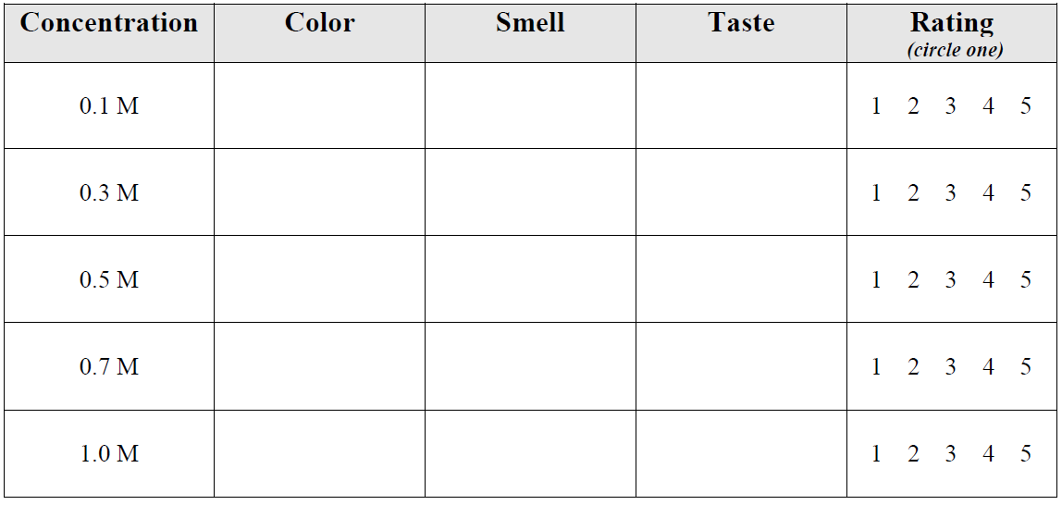
Post-Laboratory Questions

- Which concentration of Kool-Aid did you prefer the most? What was wrong with the other solutions that you made?

- How is taste related to concentration? Why are they related in this way?

- Calculate the molarity of Kool-Aid as prepared using the directions on the back of the container. The directions read: Add 88 grams (3/4 cup) of Kool-Aid powder to 1 quart of water. (1 quart=946.35 mL)

_______________

- Calculate the grams of Kool-Aid needed to make 2.3 L of 2.0 M solution.

_______________

- You prepared 10 liters of 0.7 M Kool-Aid for a meeting at work. Your boss comes up to you and says, "Nope we only serve 0.4 M Kool-Aid around here." How much water must you add (Final Volume minus Initial Volume) to fix the Kool-Aid you made so that it is 0.4 M without starting over?

_______________

